INF 286 Instructor Dr. Seth Adjei
Assignment #7 Last Name: First Name:

Grade:
Comment:

Problem 1
Create the following table, which contains statistics about fruit flies: average height and weight, and percentage with red eyes (50%);
Use CSS to style the table satisfying the following requirements:
- (20%)The table width is 75 % of the web browser window width; The table is centered in the browser window; Its border is 2 pixel wide solid black line;
- (10%)All cell (heading cells and table data cells) padding are 5 pixels; The cell border is 1 pixel wide solid black line.
Please use the following required techniques in order to provide accessibilities of the table (20%):
- Use <th> tags for table headings;
- Use <caption> tag for the table title;
- Use <scope> tag to specify the association of table cells and table row or column headers.
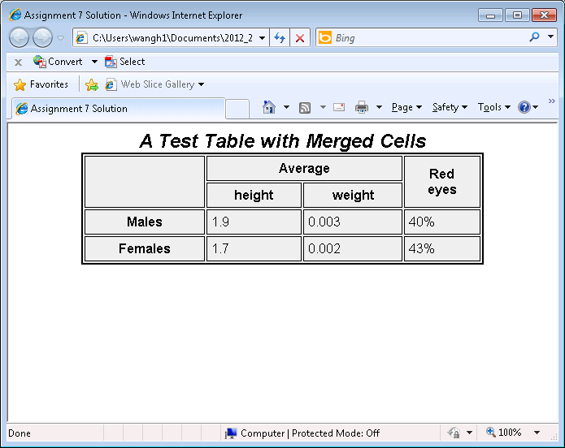
Pleaser save your code as 7.html and submit the file.

